Chapter 16, Solution 66.

For the op amp circuit in Fig. 16.89, find v_{o}(t) for t > 0. Take v_{s} = 3 e^{-5t} u(t) V.

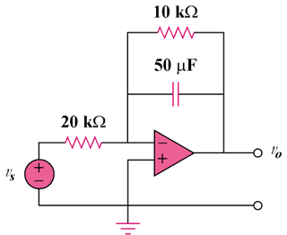

Figure 16.89
For Prob. 16.66.

Solution

Consider the op-amp circuit below where R₁ = 20 kΩ, R₂ = 10 kΩ, C = 50 µF, and

+

1/sC

R₁

R₂
+

V_{s}

0

+

V_{o}

v_{s}(t) = [3e^{-5t}]u(t) V.

At node 0,

But ,
So,

= where A = –1 and B = 1.

V.

